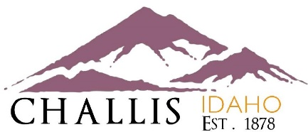
AGENDA
CHALLIS CITY COUNCIL
WEDNESDAY, JULY 06, 2022 – 5:30 P.M.
414 E. MAIN AVENUE, CHALLIS, IDAHO

SPECIAL MEETING
CALL TO ORDER
ROLL CALL
PLEDGE OF ALLEGIANCE

ORDINANCES, RESOLUTIONS & AGREEMENTS
- Airport ACTION ITEM

ADJOURN
_________________________________
Savannah Pedersen - City Clerk /Treasurer

